CHAPTER TWO

EXAMINING UNIVARIATE DISTRIBUTIONS

EXERCISES
Exercises 2.1 through 2.3 involve questions about frequency and percent distribution tables of variables in the NELS data set.

  - Create a frequency distribution table of the variable ABSENT12, which gives the number of times a student was absent in twelfth grade. Use the frequency distribution to answer the following questions.

- How many students in the NELS data set were absent 3-6 times in twelfth grade?
- How many students in the NELS data set were absent exactly 3 times in twelfth grade?
- What percentage of students in the NELS data set was absent 3-6 times in twelfth grade?
- What percentage of students in the NELS data set was absent 6 or fewer times in twelfth grade?
- How would you describe the shape of the distribution of absences in twelfth grade -- positively skewed, negatively skewed, or reasonably symmetric? Explain.

  - Create a frequency distribution table of the variable PARMARL8, which gives the marital status of the parents when the student was in eighth grade. Use it and the Data View window to answer the following questions.

- What does a score of 3 indicate on the variable PARMARL8?
- For how many students in the NELS data set was PARMARL8 = 3?
- For what percent of students in the NELS data set was PARMARL8 = 3? Interpret both the values from the percent and valid percent columns.
- Why is the cumulative percent column of PARMARL8 not meaningful?
- What is the most frequently occurring marital status for parents of students in the NELS?

  - Create a frequency distribution table of the variable FAMSIZE, which represents the number of people in a student’s household when the student was in eighth grade. Use the frequency distribution table to answer the following questions.

- What was the greatest number of people in a household for all the students in the NELS data set?
- How many students lived in households with only three members?
- How many students lived in households with at most three members?
- What percentage of the students lived in households with only three members?
- What percentage of the students lived in households with at most three members?
- Estimate Q₂ for FAMSIZE.

Exercises 2.4 through 2.7 involve questions about bar graphs of variables in the NELS data set.

  - Create a bar graph summarizing the variable GENDER. Use it to answer the following questions.

To edit the bar graph so the bars are labeled with their respective frequencies, click twice on the graph to bring it to the Chart Editor. Click Elements from the main menu bar, Show Data Labels.

- Why is a bar graph an appropriate display in this case?
- Are there more males or females in the NELS?
- What percentage of students is female?
- Would a pie graph be appropriate to depict these data?
- Note that the frequency axis starts at 0 and that the bars appear to have similar heights indicating that there are similar numbers of males and females in the data set. Let’s investigate the effect of changing the starting point of the frequency axis. Perform the following steps to have the axis start at 200 and comment upon the effect of the relative height of the two bars.

To edit the bar graph so that the frequency axis starts at 200, bring the graph to the Chart Editor. Click on any number on the vertical axis. Click on Scale in the Properties menu box. Make 200 the min and 20 the major increment. Click on Apply.

  - In this exercise, we will make separate bar graphs for males and females of the variable, ALCBINGE, which indicates whether a student has ever binged on alcohol.

To create separate graphs or analyses by a grouping variable, click Data on the main menu bar, Split File. Click the circle next to Compare Groups and move GENDER into the box. Click OK.
Then create a bar graph of ALCBINGE in the usual way.
When your grouped analyses are complete, return to Data, Split File. Click the circle next to “Analyze all cases and do not create groups” and click OK.

- What percentage of males in the NELS data set has ever binged on alcohol? What percentage of females?
- Given the two frequency bar graphs, why are the scales on the vertical axes different for the two graphs?

  - Create a bar graph for average daily school attendance rate given by the variable SCHATTRT in the NELS data set. Use the bar graph to answer the following questions.

- What appears to be problematic with the way in which the values are set along the x-axis of the bar graph?
- What is a type of graph that could be selected to display SCHATTRT that does not have that problem?
- What is the shape of the distribution of SCHATTRT?

  - This exercise is based on the Statisticians data set created in Exercise 1.15.

- Create a bar graph indicating the number of recent citations for each of the statisticians.
To generate a bar graph based on the values of individual cases, click Graphs on the main menu bar and then, Legacy Dialogs, Bar. Click the circle next to Values of individual cases. Click Define. Let the bars represent AMSTAT and label categories STATISTICIAN. Click OK.
- How did SPSS determine the ordering of categories along the X-axis?
- Use the bar graph to approximate the number of citations of Ronald A. Fisher.
- Construct a new bar graph with statisticians ordered on the x-axis according to their respective number of citations.
There are at least two ways in SPSS to create an ordered bar graph:
(1) Go to Data, Sort Cases, and move AMSTAT into the Sort by box. Click OK. Create the bar graph as in part (a).
(2) Go to Graphs in the Main Menu, then Legacy Dialogs, Bar. Click the circle next to Data in Chart are: Summaries for groups of cases. Click Define then the circle next to Other Statistic and put AMSTAT in the variable box (the default is that the other statistic is the mean). Put STATISTICIAN in the Category Axis box and click OK. The graph will have the statisticians in alphabetical order as in part (a). To place them in order of their ascending number of citations, click on the chart to get into the Chart Editor, then click anywhere on the x-axis and a “Properties” window will appear. Choose the “Categories” tab and then “Sort by Statistic” and then “Direction: Ascending” and then Apply. The graph will now have statisticians in ascending order by their respective number of recent AMSTAT citations.
- What is a useful feature of this ordered graph?
- Of the twelve statisticians, where in the ranking (from the top) is Ronald A. Fisher?
- The bar graphs constructed in parts a) and d) of this exercise depict the number of recent citations considered individually for each statistician listed separately. Construct a different type of bar graph that depicts the shape, location, and spread of the number of recent citations considered collectively across all twelve statisticians. To obtain a pleasing graph, use Chart Builder graphs and edit the graph so that the bar width is 50%. What variable is represented by the X-axis in this graph? Why is it appropriate to continue to use a bar graph for this depiction?
- Describe the shape of this distribution. Where does the center of this distribution appear to be located and what is its spread, from the minimum to the maximum value?

Exercise 2.8 involves questions about a pie graph of a variable in the NELS data set.

  - Construct a pie graph of the variable URBAN, which indicates whether in eighth grade the student lived in an urban, suburban, or rural area in the United States.

- Edit the graph so the slices are labeled by counts (values) and by percents.

To edit the pie graph, click twice on the graph to get it into the Chart Editor. Assuming that you created the graph in Legacy Dialogs, not Chart Builder, graph mode, the following instructions indicate how to label the graph. To label the slices, click Elements, Add Data Labels. Click the up arrow to move percent to the Displayed box. Count is already there. Click Apply, Close.
- How many students come from an urban area? What percentage of students comes from an urban area?
- Use SPSS to construct the associated bar graph.
- Compare the two graphs. Which do you prefer? Why?
- What have you learned about the distribution of students in this sample across urban, suburban, and rural areas?

Exercises 2.9 through 2.14 involve questions about stem-and-leaf graphs of variables from different data sets.

  - Create a stem-and-leaf of the variable MATHCOMP from the learndis data set. Use it to answer the following questions.

- What is another type of graph that could be used to depict these data?
- What is the total number of scores in this distribution?
- How many scores are in the seventies?
- Are there any outliers (i.e., extreme values) in this distribution?
- How would you describe the shape of this distribution? Explain.
- What is the 50th percentile?
- What is/are the most frequently occurring score(s) in this distribution? How many times does it/do they occur?
- What is the highest score in this distribution?
- Can we use this stem-and-leaf to obtain the original set of values for this variable?

  - Create a stem-and-leaf of the variable BIRTH from the Statisticians data set that you entered in Exercise 1.15. Use it to answer the following questions.

- How many people in the data set were born in 1900?
- Are there any outliers (i.e., extreme values) in this distribution?
- How would you describe the shape of this distribution? Explain.
- What is/are the most frequently occurring score(s) in this distribution? How many times does it/do they occur?
- What is the highest score in this distribution?
- Can we use this stem-and-leaf to obtain the original set of values for this variable?

  - Create a stem-and-leaf of the variable AMSTAT from the Statisticians data set that you entered in Exercise 1.15. Use it to answer the following questions.

- How many statisticians in the data set had 7 citations?
- How would you describe the shape of this distribution? Explain.
- What is the most frequent number of citations for statisticians in this data set?
- What is the 50th percentile for this data set?

  - Create a stem-and-leaf of the variable total cholesterol, given by the variable TOTCHOL1 found in the Framingham data set. Use it to answer the following questions.

- What is the lowest score in this distribution?
- Are there any outliers (i.e., extreme values) in this distribution? Describe them.
- How would you describe the shape of this distribution? Explain.
- What is the 50th percentile of these data?
- What is the highest score in this distribution?
- Can we use this stem-and-leaf to obtain the complete set of original values for this variable?

  - Create a stem-and-leaf of eighth grade math achievement scores given by the variable ACHMAT08 in the NELS data set. Use the stem-and-leaf to answer the following questions.

  - According to the stem-and-leaf plot, what is the lowest eighth grade math achievement score?
  - According to the stem-and-leaf graph, approximately how many students received the lowest eighth grade math achievement score?
  - According to the stem-and-leaf plot, are there any outliers (extreme values) in this distribution?
  - According to the stem-and-leaf plot, how would you characterize the shape of this distribution -- negatively skewed, approximately symmetric, or positively skewed?
  - According to the stem-and-leaf plot, which eighth grade math achievement score occurs most often?
  - What type of question is better answered with a stem-and-leaf and what type of question is better answered by a frequency distribution table?

  - Follow the instructions to create separate stem-and-leaf graphs of SYSBP1 (systolic blood pressure) for men and women (SEX) using the Framingham data set.

To obtain separate stem-and-leaf displays for different values of a grouping variable, click Analyze from the main menu bar, then Descriptive Statistics and then Explore. Move SYSBP1 to the Dependent List and SEX into the Factor List. Click OK.

- In which distribution (male or female) do we find the lowest systolic blood pressure value? Explain.
- In which distribution is the most frequently occurring systolic blood pressure value higher? Explain.
- In which, if either, distribution does systolic blood pressure have a greater spread? Explain.
- In which, if either, distribution is systolic blood pressure more skewed? Explain.

Exercises 2.15 through 2.17 involve questions about histograms of variables in the NELS data set.

  - Create a histogram of the twelfth grade math achievement given by the variable ACHMAT12 in the NELS data set. Use the histogram to answer the following questions.

- According to the histogram, what is the smallest twelfth grade math achievement score in the NELS data set? Approximately how many times does that score occur?
- According to the histogram, what is the most frequently occurring twelfth grade math achievement score interval?
- According to the histogram, what is the shape of the distribution? Explain.

  - Follow the instructions to create two side-by-side histograms for socio-economic status, given by the variable SES in the NELS data set. Let one histogram represent those did not own a computer in eighth grade and the other represent histogram represent those who did own a computer in eighth grade (COMPUTER). Use it to answer the following questions.

To create side-by-side histograms, click Graphs, Legacy Dialogs, Population Pyramid. Move SES into the Show Distribution over box and COMPUTER into the Split by box. Click OK.

- Which computer group has the single highest SES score?
- Would you say that SES is higher for the group that owns a computer? Why or why not?
- Do the SES values have more spread for one group over another?

  - Create two histograms, one for a student’s self-concept in eighth grade as given by the variable SLFCNC08 in the NELS data set and the other for a student’s self-concept in twelfth grade as given by the variable SLFCNC12 in the NELS data set. Edit the histograms so that they each have the same scale and range of values on both the horizontal and vertical axes, and use them to answer the following questions.

- For which grade (eighth or twelfth) is the overall level of self-concept higher?
- For which grade is the spread of self-concept scores less?
- For which grade is self-concept more skewed, and in which direction?

Exercises 2.18 through 2.20 involve questions about line graphs of variables in the NELS data set.

  - Create graphs using Legacy Dialogs and Chart Builder for average daily attendance rate per school as given by the variable SCHATTRT in the NELS data set. Use the graphs to answer the following questions.
- In which line graph does SCATTRT appear more negatively skewed?
- Which graph gives the more accurate portrayal of skewness in this case and why?

  - Create an ogive or cumulative line graph for the distribution of SCHATTRT. Use it to answer the following questions.

- Approximately how many students attend schools where the average daily attendance rate is less than 90 percent?
- Based on the ogive or cumulative line graph, would you describe the distribution as positively skewed, negatively skewed, or symmetric?

  - In this exercise we will see that the interpretation of a line graph can change with a change in the scale of the vertical and horizontal axes.

- Use the Marijuana data set and SPSS to construct line graph, using Chart Builder, of the percentage of students who have ever tried marijuana by year.
- Use the following instructions to compress the scale on the vertical axis.

Double click on the graph to put it into the Chart Editor. Double click on any value on the vertical axis to bring up the Scale Axis box. Unclick Auto for Minimum, Maximum, and Tick Interval. Type the value 0 for the minimum, 60 for the maximum, and 10 for the tick interval. Click OK.

What is the effect of this change on the interpretation of the graph?
- Use the following instructions to restrict the range of values on the horizontal axis to 1992 through 1999 in the uncompressed graph . Provide an interpretation of the graph.

To select cases, click Window on the main menu bar. Have the data set showing. Click Data, Select Cases. Click the circle next to If Condition is Satisfied. Click If. Type YEAR ≥ 1992 & YEAR ≤ 1999. Click Continue, OK. Now when you make the line graph, it will show the years from 1992 through 2002 only.

Exercises 2.21 through 2.23 involve questions percentiles and percentile ranks of variables in the NELS data set. In these exercises, we use the cumulative percent to estimate the percentile rank.

  - Find the following values for a student’s expected income at age 30 given by the variable EXPINC30 in the NELS data set.

- What is the exact value of the 15th percentile, according to SPSS?
- What is the exact value of the 50th percentile, according to SPSS?
- What is the approximate percentile rank of an expected income of $50,000?

  - Why is the calculation of percentiles not appropriate for the variable PARMARL8.

  - This question relates to the optimist who is expecting to earn $1,000,000 per year at age 30 (EXPINC30 = 1,000,000).

- What is this student’s ID?
- What was this student’s eighth grade self-concept score (SLFCNC08)?
- What is the percentile rank of his eighth grade self-concept score? Is it what you expected?
- Use percentile ranks to determine the grade (eighth, tenth, or twelfth) in which this student was least self-confident relative to his peers.

Exercise 2.24 deals with questions about a boxplot of a single variable from the NELS data set.

  - Create a boxplot that shows the number of times a student in twelfth grade was recorded late for school as given by the variable LATE12. Note that the level of measurement of LATE12 is ordinal. Use the boxplot and the scoring information in the data set to answer the following questions.

  - Estimate and interpret the value of the 50th percentile for LATE12, represented by the line in the middle of the box.
  - Estimate the IQR of this distribution.
  - What is the shape of this distribution? Explain by referring to the boxplot.
  - What is the significance of the fact that the graph has no bottom whisker?

Exercise 2.25 deals with questions about boxplots of more than one ordinal or scale variable constructed on the same axes.

  - Create one graph that has three boxplots, one for each of the distributions of self-concept scores for eighth, tenth, and twelfth grades, respectively. Use this graph to answer the following questions.

To obtain a boxplot for SLFCNC08, SLFCNC10, and SLFCNC12, click Graphs, Legacy Dialogs, Boxplot, Summaries of separate variables, and Define. Move SLFCNC08, SLFCNC10, and SLFCNC12 to the box labeled Boxes Represent and click OK.

- How would you describe the shape of the distribution of self-concept in eighth grade?
- For which grade is the self-concept distribution most nearly symmetric?
- Overall, which of the three grades has the highest level of self-concept?
- Which of the three grades contains the highest single self-concept score? And, what is your estimate of that score?
- Based on the interquartile range, which distribution appears to have the highest spread?

Exercises 2.26 through 2.27 involve boxplots of a single variable for different sub-groups.

  - Create four boxplots on the same axis, one for each REGION, that plots the number of years of math taken in high school as given by the variable UNITMATH of the NELS data set. Use the graph to answer the following questions.

To create a boxplot of UNITMATH by REGION, click Graphs, Legacy Dialogs, Boxplot, Summaries for Groups of Cases, and Define. Move UNITMATH into the box labeled Variable and REGION into the box labeled Category Axis. Click OK.

- Which region is most symmetric with respect to the distribution of units (years) of math taken in high school?
- In which of the four regions is the overall level of UNITMATH lowest?
- Which of the four regions contains the student with the single lowest number of units of math taken in high school? And, what is that number?
- In which region, if any, is the spread of UNITMATH smallest?
- How many of the 106 students in the Northeast have UNITMATH scores between Q₁ and Q₂? Is this number confined to UNITMATH scores or does it generalize to all variables in this data set?

  - Construct four side-by-side boxplots of the number of AP classes offered at a student’s school (APOFFER), one for each of the four types of high school programs (HSPROG) represented in the NELS data set.

- How might one explain that there are academic program schools that offer many AP courses, but not any rigorous academic program schools that offer more than 20?
- What would be a better way to represent AP courses offerings other than by their number per school?

Exercise 2.28 involves boxplots of more than one ordinal, interval, or ratio variable broken down by a grouping variable.

  - Make four side by side boxplots showing the distributions of SLFCNC08, SLFCNC10, and SLFCNC12, the self-concept scores in eighth, tenth, and twelfth grades, respectively, by GENDER.

To obtain a boxplot for SLFCNC08, SLFCNC10, and SLFCNC12 separated by gender, click Graphs, Legacy Dialogs, Boxplot, Clustered, Summaries of separate variables, and Define. Move SLFCNC08, SLFCNC10, and SLFCNC12 to the box labeled Boxes Represent and GENDER to the box labeled category axis and click OK.

- Does self-concept generally appear to be increasing from eighth to twelfth grade for both sexes?
- What is most noticeable about these boxplots when comparing males to females?
- If not for the female outliers in 12th grade, would you say that males and females are comparable in their homogeneity of self-concept in 12th grade?

Exercises 2.29 – 2.31 involve a variety of boxplots.

  - In this exercise, we review the construction of the four different types of boxplots using the NELS data set.

- Construct a boxplot of eighth grade reading achievement (ACHRDG08).
- Construct, within one set of axes, two boxplots of eighth grade reading achievement, one for males and the other for females using the variable GENDER.
- Construct, within one set of axes, three boxplots, respectively, of eighth, tenth, and twelfth grade reading achievement.
- Construct, within one set of axes, boxplots of eighth, tenth, and twelfth grade reading achievement, separately for males and females.

  - Describe the shape of each the following distributions denoted a, b, c, d, e, and f.

  - This exercise is based on the States data set, but does not require the use of SPSS. The boxplots below show, for each of the four regions, the average educational expenditure for the states in that region. The four stem-and-leaf displays, labeled A, B, C, and D show the same. For each stem-and-leaf, the stem width is 1000 and each leaf represents one case. Match the letter associated with each stem-and-leaf to the appropriate boxplot.

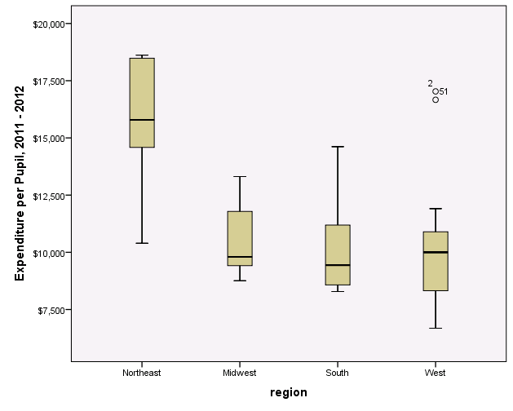

Expenditure per Pupil, 2011 - 2012 Stem-and-Leaf Plot for
region= A

Frequency Stem & Leaf

7.00 8 . 2444557
5.00 9 . 04589
.00 10 .
2.00 11 . 17
.00 12 .
1.00 13 . 9
2.00 14 . 36

Stem width: 1000
Each leaf: 1 case(s)

Expenditure per Pupil, 2011 - 2012 Stem-and-Leaf Plot for
region= B

Frequency Stem & Leaf

2.00 6 . 68
.00 7 .
2.00 8 . 23
1.00 9 . 0
5.00 10 . 00238
1.00 11 . 9
2.00 Extremes (>=16666)

Stem width: 1000
Each leaf: 1 case(s)

Expenditure per Pupil, 2011 - 2012 Stem-and-Leaf Plot for
region= C

Frequency Stem & Leaf

1.00 8 . 7
6.00 9 . 244578
1.00 10 . 8
1.00 11 . 3
2.00 12 . 14
1.00 13 . 3

Stem width: 1000
Each leaf: 1 case(s)

Expenditure per Pupil, 2011 - 2012 Stem-and-Leaf Plot for
region= D

Frequency Stem & Leaf

1.00 1 . 0
1.00 1 . 3
3.00 1 . 445
1.00 1 . 6
3.00 1 . 888

Stem width: 10000
Each leaf: 1 case(s)

Exercise 2.32 involves questions about selection of appropriate graphical displays.

  - For the following variables in the NELS data set, indicate whether the most appropriate types of graphical displays are (1) bar graph or pie graph, or (2) histogram, line graph, stem-and-leaf plot, or boxplot.

- GENDER
- URBAN
- SCHTYP8
- TCHERINT
- NUMINST
- ACHRDG08
- SCHATTRT
- ABSENT12

Exercises 2.33 – 2.34 involve a number of different topics.

  - The following questions pertain to the tenth grade social studies achievement score for students as given by the variable ACHSLS10 in the NELS data set.

- What is the highest tenth grade social studies achievement score in the NELS data set?
- How many students obtained the highest score?
- What is the most frequently occurring score in this distribution?
- What is the 50th percentile of the distribution?
- What is the 67th percentile?
- What percentage of students scored 70 or below?
- What is the shape of the distribution?

  - The following questions pertain to the amount of time spent weekly on extracurricular activities in twelfth grade as given by EXCURR12 in the NELS data set.

- What does the value 2 represent?
- How many students in the NELS data set answered EXCURR12 that they spent 1 to 4 hours per week on extracurricular activities?
- What is the value at the 50th percentile?
- What is the shape of this distribution?

Exercises 2.35 – 2.37 involve reading and interpreting graphs.

  - The line graphs below show the number of jobs in thousands and the unemployment rate for part of the time president George W. Bush was in office. The graph was released by the US Treasury Department and a good analysis of it may be found at http://www.brendan-nyhan.com/blog/2005/12/the_treasury_de.html. Answer the following questions.

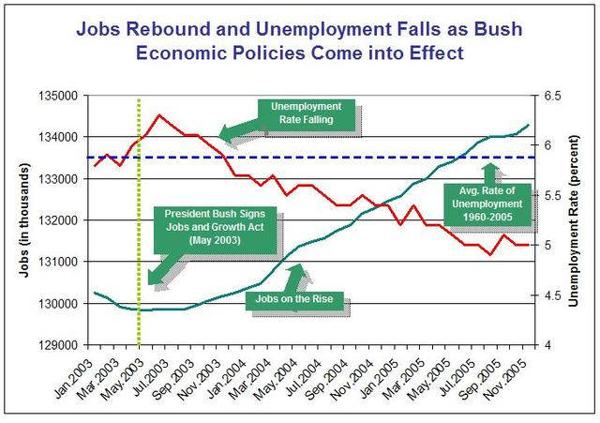

- The vertical line represents what month? Why is this month highlighted?
- What was the approximate number of jobs in March 2003? What was the approximate unemployment rate?
- Give the month and year of the lowest unemployment rate.
- Based on this graph, is it fair to say that President George W. Bush’s Jobs and Growth Act helped create jobs and lower unemployment? Explain.

  - The following graph gives the relative average speed of Mets’ baseball pitcher R.A. Dickey’s knuckleball velocity in 2012 and 2013. (http://www.huffingtonpost.com/raviparikh/lie-with-data-visualization_b_5169715.html). The graphic is reproduced here as an SPSS bar graph. Comment upon the design of this graphic.

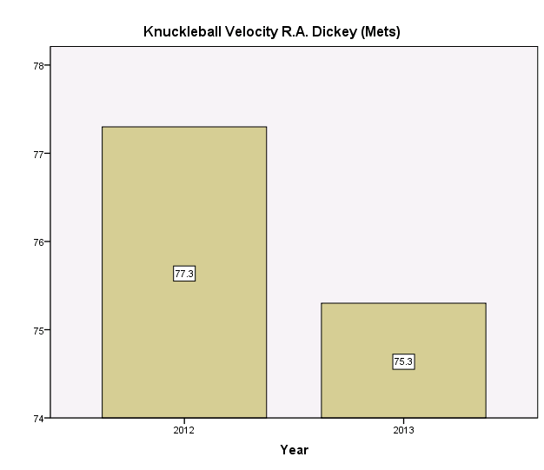

  - On June 3, 2014, H&R Block (http://blogs.hrblock.com/2014/06/03/the-things-you-can-do-but-what-should-you-do-infographic/) published pie and bar graphs, recreated here in SPSS, indicating the best and worst college majors in terms of employment prospects.

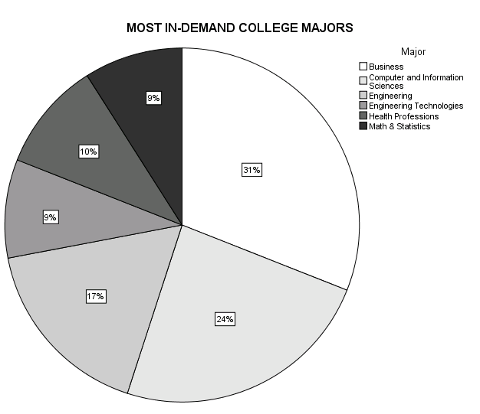

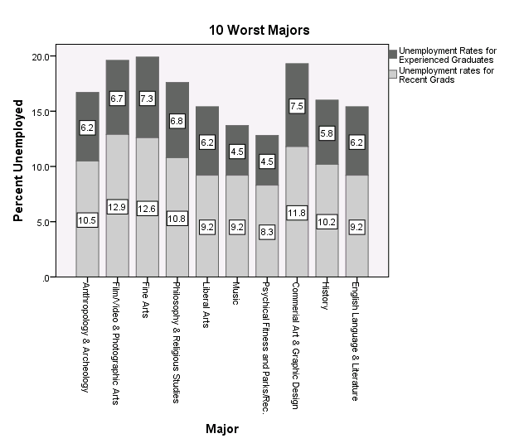

- In the pie graph, what is the interpretation of the 31 associated with the business major?
- What would be an advantage of using a bar graph instead of a pie graph to depict the most in-demand college majors?
- What percentage of recent grads who majored in anthropology and archeology are unemployed?
- Why does it make sense for this bar graph to be stacked?

Exercises 2.38 – 2.48 check your conceptual understanding of the material in this chapter, without the use of SPSS.

  - Assuming the statistics are all calculated on the same set of data, rank the following from numerically smallest to numerically largest: C₅₀ C₄ D₁ D₃ Q₁ Q₃

  - Determine what, if anything, is wrong with the following statement: A raw score of 75 is always surpassed by 25 percent of the scores in the distribution from which it comes.

  - Determine what, if anything, is wrong with the following statement: A 90-item test was scored by giving one point for each correct answer so that possible scores ranged from 0 to 90. On this test, the highest percentile rank possible is 90.

  - Determine what, if anything, is wrong with the following statement: On a certain English exam, Alice’s score is twice as high as Ellen’s. Therefore, Alice’s percentile rank on the exam must be twice Ellen’s percentile rank.

  - Determine what, if anything, is wrong with the following statement: If it takes 10 raw score points to go from a percentile rank of 50 to a percentile rank of 58, then it must also take 10 raw score points to go from a percentile rank of 90 to a percentile rank of 98.

  - Determine what, if anything, is wrong with the following statement: Scott, who scored at the 85th percentile in a math achievement test given to everyone in his school, and at the 95th percentile in a science test given to all students in the city in which the school is located, is doing better in science than in math.

  - Determine what, if anything, is wrong with the following statement: In a recent door-to-door survey, only five of the people questioned said they were opposed to a proposed school bond issue. The local school board publicized the results of this survey as evidence of tacit approval of the proposal.

  - Are the following possible values for percentiles: 50, -2, 512? Are they possible values for percentile ranks?

  - Explain how a symmetric distribution can have outliers in its boxplot.

  - Explain how a boxplot could have only one whisker.

  - Draw a picture of two side-by-side boxplots so that

  - The one on the left clearly has scores that are typically at a higher level and the one on the right has scores that are clearly less consistent. The graphs you create indicate that higher scores do not necessarily mean more spread.
  - The one on the left is clearly less spread out and the one on the right is clearly less skewed. The graphs you create indicate that more skew does not necessarily mean more spread.

CHAPTER 2 SOLUTIONS

- 180

- It is impossible to know the exact number. However, we can estimate the value by assuming that equal numbers of students were absent 3, 4, 5, and 6 times. Accordingly, the total number absent exactly 3 times in twelfth grade is estimated to be 180/4 = 45.
- 36 percent.
- 86 percent.
- Positively skewed. The bulk of students have six or fewer absences, and there are only a few students with an unusually high number of absences.

- That the student’s parents were separated at the time the student was in eighth grade.

- 8.
- Of all students that reported their parents’ marital status in eighth grade, 1.7 percent reported that their parents were separated . Of all students in the NELS data set, 1.6 percent reported that their parents were separated.
- Because PARMARL8 is nominal there is no intrinsic ordering to the categories; the numbers are assigned arbitrarily to them. As such, it does not make sense to consider the percent of people “below separated”, for example.
- Married.

- 9.

- 52.
- 9 + 52 = 61.
- 10.4 percent.
- 12.2 percent.
- Q₂ is approximately 4.

- GENDER is a nominal variable.

- There are more females. There are 273 females and 227 males.
- percent.
- Yes. Every person in the data set is classified as either male or female, so the categories are mutually exclusive and exhaustive.
- The effect of the change in starting point on the vertical axis is that it appears that there is a greater difference in the number of people of each gender in the data set.

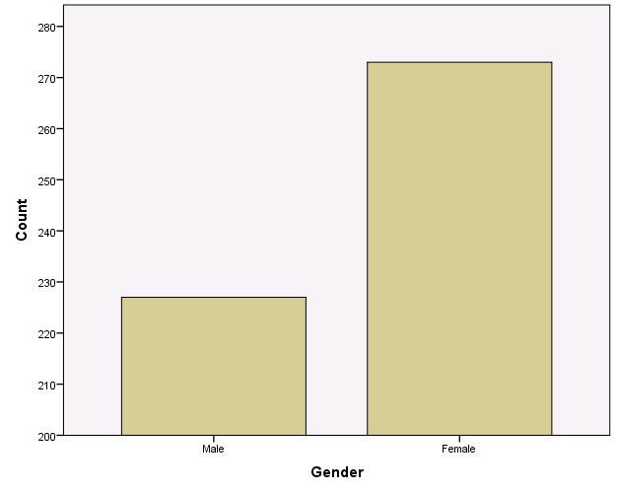

  - For this solution, the graph was edited so that the bars are labeled with exact counts. If you do not do that, your answer will be an approximation of the answers given.

- For males the answer is: (66/227) x 100 or 29.1 For females the answer is: (42/273) x 100 or 15.4 percent.

- To accommodate the larger number of females who had never binged on alcohol.

- The values are not equally-spaced, making it difficult to judge the shape of the distribution, in general, and the distance of the values in the lower tail from the bulk of the distribution, in particular.
- A stem-and-leaf, histogram, or interactive line graph.
- The shape of the distribution is negatively skewed, even more negatively skewed than it appears to be given the unequal spacing of values along the x-axis. Most schools have attendance rates above 90 percent; however, there are two schools with attendance rates below 50 percent.

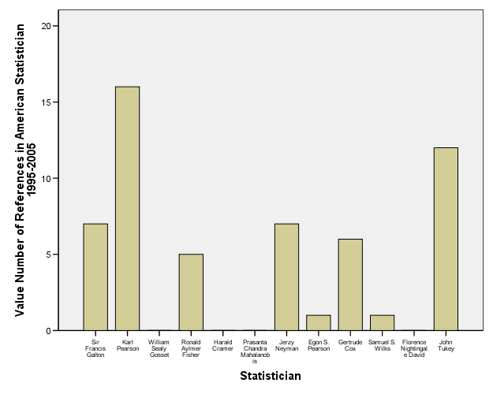
- The ordering of categories along the X-axis corresponds to way in which the data were input into the data file.
- 5.

- It is useful for ranking statisticians by their respective number of recent citations as recorded in The American Statistician.
- He is 6th from the top.
- The variable, number of recent citations/references, is represented by the X-axis in this graph. Since this variable is discrete, with a relatively small range of values, a bar graph would continue to be appropriate.
- The distribution appears to be skewed positively, with a center at approximately 5 references (there are five values above 5 and six values below 5), and a spread from 0 to 16 references.

- 123 students, or 24.6 percent, come from an urban area.

- There is no “correct” answer to this question. It is a matter of preference.
- Most students are from suburban areas, followed by rural, and the fewest are from urban areas.

Math Comprehension Stem-and-Leaf Plot

Frequency Stem & Leaf

2.00 6 . 12
7.00 6 . 6678999
9.00 7 . 002223334
19.00 7 . 5566777777888888889
12.00 8 . 000122444444
8.00 8 . 56667789
12.00 9 . 011222333333
10.00 9 . 5566777788
6.00 10 . 001333
1.00 10 . 8
3.00 11 . 223
4.00 11 . 5678
1.00 12 . 1

Stem width: 10
Each leaf: 1 case(s)

- The variable is interval, so a line graph, histogram, or boxplot, could also be used.
- 2 + 7 + 9 + 19 + 12 + 8 + 12 + 10 + 6 + 1 + 3 + 4 + 1 = 94.
- 9 + 19 = 28.
- No.
- It is reasonably symmetric. The two tails are about equal in size and there are no outliers.
- Because there are an even number of scores (94), the 50th percentile is the average of the two middle scores, which are in the 47th and 48th positions. Both of these values are 84, so the 50th percentile is 84.
- 78; it occurs 8 times.
- 121.
- Yes.

Year of Birth Stem-and-Leaf Plot

Frequency Stem & Leaf

1.00 Extremes (=<1822)
1.00 185 . 7
.00 186 .
1.00 187 . 6
.00 188 .
5.00 189 . 03345
3.00 190 . 069
1.00 191 . 5

Stem width: 10
Each leaf: 1 case(s)

- 1.
- Yes. One statistician was born on or before 1822.
- The distribution is negatively skewed because of the low outlier.
- Two statisticians were born in 1893. No other pair of statisticians was born in the same year.
- 1915.
- No. The exact value of the outlier cannot be determined from the display.

Number of References in American Statistician 1995-2005 Stem-and-Leaf Plot

Frequency Stem & Leaf

6.00 0 . 000011
4.00 0 . 5677
1.00 1 . 2
1.00 1 . 6

Stem width: 10
Each leaf: 1 case(s)

- 2.
- The distribution is positively skewed despite the fact that there are no outliers. Most statisticians have fewer than 8 citations, but two have more than 10 citations.
- The most frequently occurring number of citations is 0.
- The 50th percentile is (1+5)/2 = 3.

Serum Cholesterol mg/dL (1) Stem-and-Leaf Plot

Frequency Stem & Leaf

1.00 1 . 3
4.00 1 . 5555
24.00 1 . 666666666666677777777777
52.00 1 . 8888888888888888888899999999999999999999999999999999
62.00 2 . 00000000000000000000000000011111111111111111111111111111111111
68.00 2 . 22222222222222222222222222222222222233333333333333333333333333333333
74.00 2 . 44444444444444444444444444444444444455555555555555555555555555555555555555
46.00 2 . 6666666666666666666666666666777777777777777777
31.00 2 . 8888888888888899999999999999999
16.00 3 . 0000000011111111
9.00 3 . 222223333
3.00 3 . 444
2.00 Extremes (>=353)

Stem width: 100
Each leaf: 1 case(s)

- The exact value of the lowest score cannot be determined because it has been truncated to 130. All we know is that the exact value is between 130 and 140, inclusive.
- Yes. There are two people with initial cholesterol levels that are greater or equal to 353.
- Positively skewed due to the two high outliers.
- Approximately 230. This stem-and-leaf plot reports values rounded to two significant digits, so that a value of 233, for example, is reported as 230. Given that there are 392 scores in this stem-and-leaf, the 50th percentile for these data, based on this stem-and-leaf, is estimated to be 230, which is the average of the 196th and 197th scores in this distribution. The 196th and 197th score each has a recorded value of 230.
- The exact value of the highest score cannot be determined because it is recorded simply as an extreme value, noted to be greater than or equal to 353.
- No, for two reasons. First, the scores are rounded to two significant digits and so we would not know the actual units digit of each value (e.g., an original score of 253 would be represented in this stem-and-leaf as 250). Second, we do not know the values of the two outliers.

Math Achievement in Eighth Grade Stem-and-Leaf Plot

Frequency Stem & Leaf

12.00 3 . 78899&
47.00 4 . 0000112222233333444444
73.00 4 . 555555666666667777777788888889999999
101.00 5 . 0000000001111111122222222222333333344444444444444
81.00 5 . 555555566666666677777777788888888889999
77.00 6 . 0000000001111111222222223333334444444
70.00 6 . 5555555666666667777777788888899999
28.00 7 . 000123334444
11.00 7 . 55777

Stem width: 10.00
Each leaf: 2 case(s)
& denotes fractional leaves.

  - Approximately 37. The scores in the data set are given to two places after the decimal, but the stem and leaf plot reports only the two leading digits.
  - Approximately two, because there is a single leaf and each leaf is noted to represent two cases.
  - No.
  - Approximately symmetric.
  - 54.
  - For general questions about the shape, level, and spread of a distribution, a stem-and-leaf plot provides a better visual summary of the distribution. However, when exact frequencies and variable values are desired, the frequency distribution table often provides a greater level of detail.

Systolic BP mmHg (1) Stem-and-Leaf Plot for
SEX= Men

Frequency Stem & Leaf

2.00 9 . 89
3.00 10 . 012
13.00 10 . 5555777788889
24.00 11 . 000001111122222233344444
22.00 11 . 5555556666777889999999
22.00 12 . 0001111112222223444444
20.00 12 . 55566677777777888999
26.00 13 . 00000000011112222222333344
16.00 13 . 5566677778888999
14.00 14 . 00001111123444
6.00 14 . 566789
4.00 15 . 0023
9.00 15 . 567899999
4.00 16 . 0222
2.00 16 . 78
4.00 17 . 1234
1.00 17 . 5
8.00 Extremes (>=179)

Stem width: 10
Each leaf: 1 case(s)

Systolic BP mmHg (1) Stem-and-Leaf Plot for
SEX= Women

Frequency Stem & Leaf

1.00 9 . 2
5.00 9 . 56778
13.00 10 . 0000002233334
18.00 10 . 555567777778888999
17.00 11 . 00001122233333444
19.00 11 . 5555666666778888999
20.00 12 . 00000012223333334444
27.00 12 . 556666677777778888889999999
21.00 13 . 000111222222222333344
13.00 13 . 5566778899999
10.00 14 . 0000111223
4.00 14 . 6788
5.00 15 . 02234
4.00 15 . 5589
3.00 16 . 001
4.00 16 . 5558
3.00 17 . 033
2.00 17 . 66
11.00 Extremes (>=178)

Stem width: 10
Each leaf: 1 case(s)

- Female. For males, the lowest systolic blood pressure value is 98, while for females it is 92.
- Female. In the female distribution, the most frequently occurring systolic blood pressure is 132, while in the male distribution, it is 130.
- The distributions appear to be quite similar in spread.
- The shapes of the distributions appear to be quite similar; they are both similarly positively skewed.

- Estimating from the histogram, the lowest score is approximately 34 and it appears 2 times.
- Between 54 and 55.
- It is slightly negatively skewed. There is a longer tail on the left than on the right.

- The group that owned a computer in eighth grade.
- Yes, it appears to be higher for the group that owns a computer as the distribution for this group begins and ends at a higher point along the ses scale and the bulk of the scores in that distribution is located higher up on the ses scale than for the other group.
- No. The spread of the two distributions appears to be quite similar.

- The level of self-concept is higher for the twelfth grade – the bulk of the scores in the histogram for twelfth grade is further to the right on the x-axis than for eighth grade.

- In eighth grade the scores are more closely clustered.

- The scores are more negatively skewed in twelfth grade – the tail is longer in the negative direction or to the left.

- In the interactive line graph.
- The interactive line graph. The regular line graph gives a distorted view due the way in which values are formatted along the x-axis. The distance between values on the x-axis shrinks toward the lower end of the tail.

- Approximately 75.
- Negatively skewed.

- The compressed scale reduces the appearance of a change in the percentages of students who use marijuana over time. Said differently, student behavior with respect to smoking marijuana appears to be more consistent over time with the compressed scale.
- The percentage of seniors who have tried marijuana increases rather dramatically from 1992 through 1999.

- $30,000. This means that 15 percent of the students are expecting to be earning less than $30,000 at age 30.
- $40,000.
- 73.9.

  - Because PARMARL8 is only nominal. Variables must be at least ordinal-leveled for percentiles to be meaningfully calculated.

- 102.
- 25.
- According to the frequency distribution table, the percentile rank of his eighth grade self-concept score is 74.8 inclusive. While higher than almost three-fourths of the individuals in the data set, one might have expected this person’s self-concept to be even higher.
- He was least self-confident in twelfth grade. In eighth grade, his self-concept score of 25, gave him a percentile rank of 74.8 percent. In tenth grade, his self-concept score of 32, gave him a percentile rank of 88 percent. In twelfth grade, his self-concept score of 22, gave him a percentile rank of 7.2 percent.

  - The value of the 50th percentile is 1. Since the value 1 corresponds to being late one or two times, we know that half the students in the NELS study were late to school no more than only one or two times.
  - The value of the IQR is the box height, or 2 – 0 = 2.
  - The graph is positively skewed because there is a long whisker above the box and no whisker at all below the box.
  - The minimum score is the same as the 25th percentile score. That is, at least 25% of students in the NELS data set were never late in twelfth grade.

- Negatively skewed. All of the outliers are on the more negative end of the scale.
- Eighth grade.
- Twelfth grade as measured by the 50th percentile.
- The twelfth grade distribution contains the highest self-concept score, which is approximately 43.
- Twelfth grade.

- West.
- West.
- There is a student in the Northeast that took only one year of math in high school.
- The distributions of all regions appear to be similar in spread according to the interquartile range.
- Because 25 percent of the scores in any distribution fall between Q₁ and Q₂, the number of students in the Northeast whose scores fall between these two quartiles will be .25x106 or approximately 27 for those in the Northeast regardless of the variable in question.

- Schools that offer only rigorous high school academic programs are likely to be smaller in scale (e.g., they may be non-public schools) than those that offer academic programs, which could explain the relatively smaller number of AP course offerings overall.

- By using the percentage of all course offerings per school.

- Yes.
- The large presence of extremely low self-concept scores for females as compared to males.
- Yes. Box and whiskers are themselves comparable for males and females.

- Positively skewed. .
- Negatively skewed.
- Slightly positively skewed.
- Positively skewed.
- Positively skewed.
- Positively skewed.

- South
- West
- Midwest
- Northeast

- (1) The variable is nominal.
- (1) The variable is ordinal with only three categories.
- (1) The variable is nominal.
- (1) or (2) The variable is interval, so (2) is appropriate, but it takes on only four values, so (1) is also appropriate.
- (1) or (2) The variable is ratio, so (2) is appropriate, but there are only four categories, so (1) is also appropriate.
- (2) The variable is interval and takes on many values.
- (2) The variable is ratio and takes on many values.
- (1) or (2) The variable is ordinal, so (2) is appropriate, but it takes on only six values, so (1) is also appropriate.

- 72.89.
- 13 students scored 72.89.
- 72.89.
- 55.7.
- 59.9.
- 94.9 percent.
- According to the histogram, it is reasonably symmetric.

- 1 – 4 hours was spent weekly on extracurricular activities in twelfth grade.

- 125.
- 1 – 4 hours.
- Slightly positively skewed. The bulk of the students spend less than 20 hours per week on extracurricular activities, but a few students spend quite a bit more than that.

- May 2003. It is highlighted because it is when President Bush signed the Jobs and Growth Act.
- 130,000,000 and 5.7 percent.
- August 2005.
- It is not fair to conclude that. Among the most serious flaws with the graph is the restriction of the time range. It depicts fewer than two of the eight years President Bush was in office. In a graph created by Brendan Nyhan, we see that a longer time frame shows that President Bush’s term began with an unemployment rate that was lower than it was even after the Jobs and Growth Act took effect.

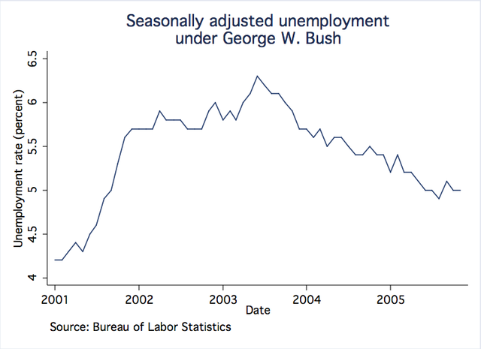

Even though there is only a relatively small difference between the velocities, the graphic accentuates the difference because the vertical axis does not start at 0, one bar is about twice the height of the other, making it appear that Dickey’s knuckleball was twice as fast in 2012 than it was in 2013 When the graph is edited so that the vertical axis starts at 0, the comparison is more accurate.
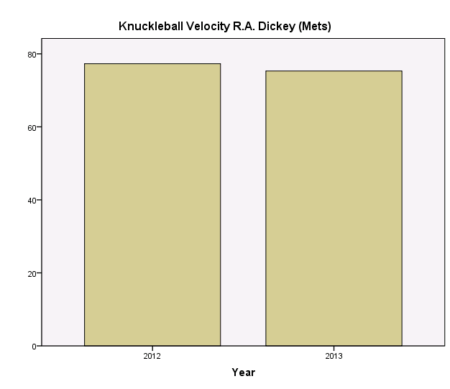

- 31% of the students in one of the top six most in-demand college majors majored in business.
- The pie graph implies that the percentages are out of a meaningful whole. Instead, a bar graph of counts could give us a sense of the relative sizes of these majors without implying that there are not any others.
- 10.5%.
- Assuming that recent graduates and experienced graduates can be combined to represent all graduates in a certain time period it makes sense for this bar graph to be stacked.

  - C₄ D₁ Q₁ D₃ C₅₀ Q₃

  - The statement is wrong. For example, if everyone scores 10, then a raw score of 75 is not surpassed by any of the scores in the distribution. A raw score does not, in general, give information about percentages.

  - The statement is wrong. For example, if 100 people take the test, then the highest percentile rank possible is 99, that is, the highest score will have 99 percent of the scores falling below it, unless there is a tie.

  - The statement is wrong. This depends on the percentage of people below Alice’s and Ellen’s scores. For example, if there were 10 people taking the exam and eight people scored 40, Alice scored 50, and Ellen scored 100, then the percentile rank of Alice’s score is 80, while the percentile rank of Ellen’s score is 90, not twice that of Alice’s score. Of course, a percentile rank can never be 100 or above.

  - The statement is wrong. Percentiles are not necessarily interval.

  - The statement is wrong. If the students at this student’s school are exceptionally good in math, having a percentile rank of 85 in math relative to this school could be better than having a percentile rank of 95 in science relative to the entire city.

  - The statement is wrong. The validity of the conclusion depends on the number of people questioned. Whereas 5 out of 5 is 100 percent, 5 out of 100 is only 5 percent. A description in terms of relative frequency or percentage would probably be more appropriate in this situation than a description in terms of frequency.

  - They are all possible values for percentiles. Only 50 is a possible value for a percentile rank.

  - A distribution with outliers that are balanced in both the positive and negative directions can be symmetric.

  - A boxplot would have only one whisker, for example, if the 75th percentile was the same as the maximum score, that is, if the top 25 percent of the scores in the distribution were all the same value.

